Therapeutic Examination
Dr Nigel Bird MB BS MRCP DCH DRCOG DFFP PGCert Ed
Senior Partner and GP trainer, Beaconsfield Medical Centre, 175 Preston Road, Brighton BN1 6AG, nigel.bird@nhs.net, Tel: 01273 552212 Fax: 01273 564626

Much important work has been written about the importance of the consultation^{1,2} but the bulk of this has concerned the key elements of building a rapport and taking a history, along with the structure of the consultation as a whole, with examination relatively ignored. Whilst an experienced doctor will indeed make most diagnoses on the basis of a careful analysis of symptoms, with examination tending to be used to confirm or refute initial impressions, I believe that the process of examination itself is worthy of further attention, as it has an important part to play in the consultation as a whole. Patients generally expect to be examined for physical problems, and may feel that they have not been properly assessed if they have not been examined, if only a cursory examination has been undertaken, or the elements of the examination have not met their expectations. Teaching at medical school largely focusses on the primary purpose of examination, which of course is to elicit physical signs in order to support or rule out potential diagnoses from a differential developed after taking a careful history from the patient. However, there is a secondary purpose, which is therapeutic, as the process of the examination itself can have a significant impact on how the patient feels subsequently.
The importance of process can easily be overlooked in the search for physical signs, but I believe merits further consideration in its own right, particularly for post-graduate students (such as GP registrars) who are honing the basic examination methods they learnt in medical school and developing their own styles of examination.
There are many historical and contemporary examples of doctors or other health practitioners with loyal followings despite having little evidence for the treatments they prescribe, and there may be elements we can learn from the process of their consultations which we can utilise in conjunction with evidence-based treatments (when available) to improve patients’ outcomes. Every culture has a ‘medicine man’ or equivalent, with the person in question respected by the other members of the group for their perceived special knowledge in the assessment and treatment of disease. There may be overlap with spiritual leadership, and their methods may involve a great deal of ritual and sometimes the use of trance states. The concept of ‘doctor as drug’ is often quoted to students, but usually without explicit instructions on how they might achieve this beneficial effect. Some students might be concerned that what I am suggesting could feel like a deception, akin to deliberately prescribing a placebo when the patient believes they are being prescribed a drug with an active ingredient, but I regard it as simply a matter of following culturally correct process in order to obtain the best possible outcome for the patient.
This aspect of professionalism tends to be taught unconsciously by experienced clinicians acting as role models³ and most of us will easily be able to recall a physician or surgeon from medical school or whilst we were in early post-graduate training whose bedside manner we wanted to emulate. Whilst this is a valuable method of learning, I think that the process can also be broken down into elements and analysed individually to help medical students and doctors in training develop their skills in this area.
The first element is to look like a doctor – or more specifically, to fulfil the cultural expectation of what a doctor should look like in the place you are working. Clearly there is some variation possible within the cultural constraints to allow some individual expression, but marked deviation from the expectation (for example, excessive scruffiness or eccentric fashion) would put up an early barrier. There have been a number of studies examining this aspect, and in a recent systematic review of 30 hospital-based studies from 14 countries⁴, the authors concluded that ‘although patients often prefer formal physician attire, perceptions of attire are influenced by age, locale, setting and context of care.’ One illustrative example is that they found that older patients, especially those from Europe and Asia, tended to prefer doctors in white coats, whereas this trend was less clear in the USA. However, this expectation is subject to cultural change, as in the UK, where wearing of white coats by doctors was widespread in all specialities 60 years ago, but has gradually been abandoned, initially by psychiatrists, then general practitioners, and in the last generation (because of concerns about infection control) in hospital also, where additional changes have been made for the same reasons, including a ban on neck-ties and an insistence on bare forearms. A Scottish study of patients’ attitudes to their general practitioners’ attire⁵ came to similar conclusions to the hospital-based review, in that ‘overall, patients seemed to favour a more formal approach to dress’ and ‘although there are more important attributes for a general practitioner than the way he or she dresses, a majority of patients (64%) thought that the way their doctor dressed was very important or quite important’ so ‘given that 41% of the patients said they would have more confidence in the ability of one of the doctors based on their appearance, it would seem logical for doctors to dress in a way that inspires confidence.’ An additional factor (which may seem obvious but can easily be overlooked) is for the doctor to wear sufficient layers to ensure that their hands are maintained at the correct temperature for examination, which should be pleasantly warm, and not cold or hot and sweaty. As well as the element of comfort for the patient, cold hands tend to cause the patient to tense during abdominal examination, as a result of which the examining doctor risks missing subtle physical signs, whereas sweaty hands can give the impression of nervousness or lack of confidence.
The second element is to act like a doctor. All UK doctors should in any case follow the General Medical Council guidance as set out in ‘Duties of a Doctor’⁶, categorised in the four domains of ‘knowledge, skills and performance’, ‘safety and quality’, ‘communication, partnership and teamwork’ and ‘maintaining trust’. In the context of therapeutic examination, the doctor should appear calm and confident, knowledgeable and unhurried, but also efficient with the process of examination, which should be so well-rehearsed that it seems to be second nature.
The third element is to have the correct equipment to be able to examine the patient effectively, ideally in a ‘proper doctor’s bag’; by which I mean bag which fulfils the local cultural expectation of what a doctor should carry, and is easily recognisable as such - for example, in the UK, a variant of the classic Gladstone bag. (See appendix 1 for a photo for my bag.) It is surprising how many doctors do not equip themselves adequately, particularly for neurological examinations. By contrast, during the course of their apprenticeship, tradesmen such as carpenters typically build up a special set of tools with which they are very familiar and can work efficiently. See appendix 2 for suggested contents of the bag for an urban general practitioner, excluding details of emergency drugs, which have been covered recently elsewhere⁷. Additional tools may be needed, depending on the work setting; for example, rural GPs are likely to need a wider range of equipment in their car for visits (including obstetric forceps and resuscitation equipment) if the nearest ambulance station or hospital is a long way away, so that they can deal with emergencies whilst waiting for an ambulance to arrive.
The fourth element is the process of physical examination itself. During several stages of physical examination, particularly of the chest and abdomen, we have an opportunity to control the patient’s breathing pattern in a way that can be therapeutic. We ask them as a matter of course to breathe in and out for respiratory examination, and also during abdominal examination when feeling for the liver and spleen. Breathing exercises are commonly used in meditation, yoga and hypnosis in order to facilitate a trance state, and elements can be borrowed from these to lead the patient towards a light trance, during which reasonable suggestions are likely to be accepted less critically, as in hypnosis⁸. This should involve the instructions to breathe being delivered in a calm and quietly confident tone, with rising intonation for inspiration, and falling intonation for expiration and a slightly longer expiration phase, using a 7-11 approximation, i.e. seven counts for the breath in, and eleven for the breath out⁹. In addition, it can be helpful to match the timing of your breathing pattern with the patient’s as you do this. Sometimes it is necessary to ask a patient to hold a breath for a period of time and then let it go (for example, with the patient sitting forwards with the breath held in expiration in order to facilitate hearing aortic murmurs at the upper left sternal edge) and this too is a breathing exercise sometimes used in meditation, yoga and hypnosis.
‘Breathe in…….and out………..’

In addition to breathing control, touch is an important element; many aspects of examination require a physician to touch the patient, and when this is done as part of a well-rehearsed and efficient examination, with hands at the correct temperature, a patient will tend to relax somewhat, making it easier for the physician to detect subtle physical signs. I have noticed that when examining the cardiorespiratory systems in a standing patient, they tend to sway when light pressure is applied to the chest with the stethoscope, so to avoid this, I steady them using a light grip on one shoulder with the index finger and thumb of one hand whilst applying the stethoscope with the other, thus exerting a subtle element of positive control. Touch is also a vital part of orthopaedic examination, in the latter two-thirds of the classic ‘look, feel, move’ triumvirate, and most patients would expect to be examined if presenting with joint problems. All GP registrars should develop an efficient routine for examining key joints and joint systems, particularly the shoulder, knee and spine, so that important physical signs can be easily detected in a confident and well-rehearsed schema.
The use of special tools is also an important part of the examination process. All physicians have undertaken a long training with a large scientific component, and physical signs should be recorded accurately where appropriate, rather than guessing or estimating; for example, using a tape measure or ruler to measure skin lesions, which can also be examined closely using a magnifying glass, and a photograph taken if necessary (with the patient’s consent) for inclusion in their notes. Similarly, a goniometer should be used to measure the angle of restriction of joints accurately. For ENT examination, a 512Hz tuning fork should be available in the doctor’s bag for Rinne’s and Weber’s tests, and additional physical tests should be mastered for distinguishing different causes of dizziness, particularly Hallpike’s test (for benign positional vertigo) and the impulse test (for labyrinthitis).
A neurological examination is often required for patients with complex symptomatology, and this is worthy of specific attention. To the layman, it is probably the most mysterious part of clinical examination, and if performed well, can be reassuring for both doctor and patient when ruling out significant underlying pathology in those presenting with odd neurological symptoms. All medical students have to learn the full neurological examination prior to their final exams, but many GP registrars find this daunting in regular practice because of the time it takes, particularly in the context of trying to develop the skill of fitting a consultation into ten minutes (as they must do before the end of their ST3 year) which can result in a patchy neurological examination done with poor focus. I was fortunate to spend six months at a regional neurological centre during my medical SHO rotation, and one of my enduring memories of that is seeing skilled neurologists at work using a very efficient and refined examination schema, starting with screening examination techniques and leading on to highly focussed examination of specific areas in order to make an accurate clinical diagnosis. There are several of these screening examinations available on YouTube¹⁰ and I advise all my registrars to learn one and incorporate it into their regular practice.
The final touch of the examination is also worthy of consideration – momentarily slightly firmer for a second or so before lifting off, perhaps with a slight nod of the head, followed by a non-specifically positive comment, such as: ‘Good…now slip your things back on, and come and sit back down when you’re ready ’ followed by the brief ritual of washing the hands before returning to the consultation desk to summarise the physical findings and suggest or negotiate a management plan in partnership with the patient.
Examination of children is a special situation that requires an adaptation of the process. For most young children, a visit to the doctor will be quite a memorable event, and the child may well have been briefed beforehand by his parents on how he is expected to behave in the presence of the doctor. There may be negative associations to be overcome, particularly if an immunisation given recently at the surgery is fresh in the child’s memory. A toy box (containing a selection of interesting toys that can be cleaned easily with hard surface wipes) and children’s books on a low accessible shelf in the room are essential, and I recommend having one special toy on the desk also. (Mine is a plastic crocodile with a light in his mouth, activated on opening his mouth by squeezing his tail.) Ideally babies should be engaged as soon as they enter the consultation room (for example, by opening the eyes wide and making an ‘ooh’ shape with the mouth) and during examination (for example, by rolling eye movements) which can distract them effectively and make it easier to detect physical signs. It is important to be flexible about the order of examination, starting with something easy (for example, auscultation of the chest) in order to gain their confidence, avoiding conflict with the child as far as possible by changing tack or moving quickly on to something else if they start to become agitated. A common error by inexperienced registrars is to ask the child: ‘Is it okay if I examine you now?’ as this gives the child the option of saying ‘No’ and creating a block. It is better if asking anything to use a double bind, in which any available answer is one that will allow you to proceed (for example, ‘Shall I listen to the front or back of your chest first?) although even this gives a shy child an opportunity to become confused and lose confidence, so it is probably better still to proceed with gentle but firm confidence, explaining to the child in simple terms what you are doing as you go along, and ideally getting down to their level whilst doing so. A younger child will often feel more comfortable sitting on a parent’s lap for examination, and it can be helpful to suggest this to a less experienced parent before starting the examination. An additional consideration with paediatric examination is that the child’s parents will be scrutinising you throughout the consultation, and a well-rehearsed schedule of examination of the child is an important part of establishing their confidence in you.
In summary, the primary purpose of examination remains to elicit physical signs in order to confirm or refute differential diagnoses generated by taking a careful history from the patient, but a skilled doctor can also use the process of examination for therapeutic effect, and this aspect can be broken down into elements to help GP registrars develop their own examination skills and understand the importance of process, as stated succinctly in William Osler’s dictum: ‘The good physician treats the disease; the great physician treats the patient with the disease.’

References

¹ Neighbour R. The Inner Consultation: How to Develop an Effective and Intuitive Consulting Style, 2nd edition. Boca Raton: CRC press/Taylor & Francis; 2004.
² Tate P. The Doctor's Communication Handbook, 6th Edition. Boca Raton: CRC press/Taylor & Francis; 2009.
³ Spencer J. Teaching about professionalism. Med Educ 2003; 37 (4): 288–289.
⁴ Petrilli C M, Mack M, Petrilli J J, Hickner, Saint S, Chopra V. Understanding the role of physician attire on patient perceptions: a systematic review of the literature. BMJ Open 2015 5:e006578 doi:10.1136/bmjopen-2014-006578.
⁵ McKinstry B, Wang J. Putting on the style: what patients think of the way their doctor dresses. BJGP 1991; 41 (348): 270-278.
⁶ General Medical Council. http://www.gmc-uk.org/guidance/good_medical_practice.asp (accessed 20 October 2015).
⁷ Care Quality Commission. Nigel's surgery 9: Emergency drugs for GP practices. http://www.cqc.org.uk/content/nigels-surgery-9-emergency-drugs-gp-practices (accessed 20 October 2015).
⁸ Heap M, Kottiyattil A. Hartland's Medical and Dental Hypnosis, 4th edition. London: Churchill Livingstone; 2001.
⁹ Griffin J,Tyrrell I. How to master anxiety. Chalvington, East Sussex, UK: Human Givens Publishing; 2010.
¹⁰ Ingram M. Three minute neurological examination.
https://www.youtube.com/watch?v=fgwN1P5PDaA (accessed 20 October 2015).

Appendix 1

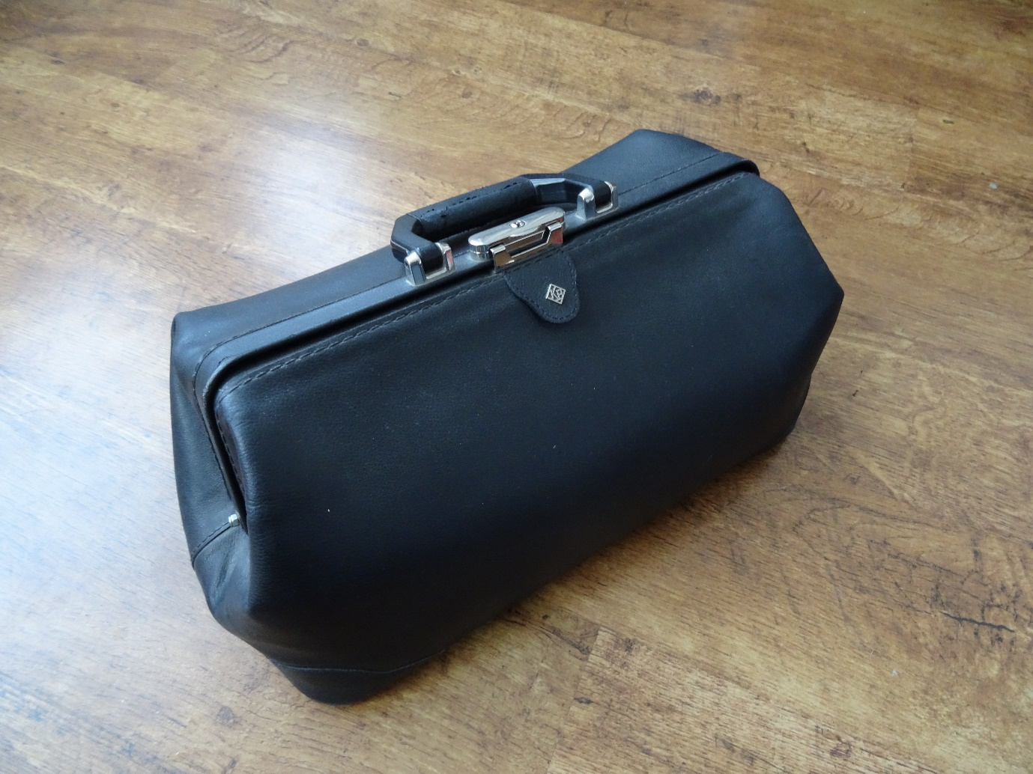

Appendix 2
Good quality stethoscope (e.g. Littmann)
Anaeroid sphygmomanometer
Ophthalmoscope and otoscope – the best you can afford
Good quality reflex hammer (e.g. Prestige Queensquare Hammer 36cm) – the small stubby ones are not suitable
Tape measure in a tidy rewinding case
Bright torch (e.g. Maglite)
Oxygen saturation monitor
Sterile needle (to be blunted before use)
Monofilament
Tuning forks (512Hz for Rinne’s and Weber’s test, 126Hz for vibration sense and temperature)
Red hat pin (for visual fields)
Goniometer
Magnifying glass for examining skin lesions
Pregnancy calculator disk
Paper bag (for hyperventilators)

